Guide to the identification
of wood-boring insects

Whilst every care has been taken to ensure the accuracy of the contents and data contained within this publication, no guarantee or liability is assumed for the information given.

All rights reserved. No part of this book may be reproduced or utilised in any form or by any information storage and retrieval systems, without permission of the publishers.

COMMON FURNITURE BEETLE

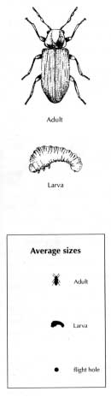(Anobium punctatum)

Timbers attacked
Sapwood of hardwoods and softwoods, plywood, wattling.

Damage
Tunnelling in sapwood tends to run along the grain. Tunnels relatively short and contain a loose bore dust. Bore dust feels 'gritty', and under magnification it is uniform in colour and contains 'lemon' shaped pellets.

Exit holes are round, about 1.5 - 2mm diameter.

Life cycle (3+ years)
- Adult: Emerge May to August and mate
- Eggs: Laid in cracks, crevices,
end grain, old exit holes; white, lemon shaped.
- Larva: Bores straight into wood
from egg: feed and grow for 3 or more years.
Larvae reach 6mm in length.
- Pupa: Develop below surface of
wood. Pupal stage is 6-8 weeks prior to emergence.

Notes:
Damage can be confused with Ambrosia beetle, Waney Edge Borer and Weevil.

Quick Identification:
Short tunnels, lemon shaped pellets present in gritty bore dust.
WANEY EDGE BORER

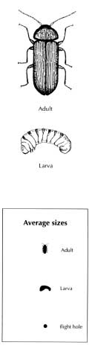(Ernobius mollis)

Timbers attacked
Partly or fully seasoned softwoods with bark present.

Damage
Confined to the bark with very superficial tunnelling in the outer sapwood; emergence holes rarely further than 15mm from barked area. Holes about 2mm in diameter. Bore dust 'gritty' feel; small 'bun-shaped' light and dark coloured pellets.

Life cycle (1 - 2 years)
- Adult : Emerge May - August and lay eggs.
- Eggs: Laid in bark; white,
lemon shaped.
- Larva: Bores and grows first in bark; may also superficially attack outer sapwood and this gives rise to the dark and light coloured pellets.
- Pupa: Develops in bark/
sapwood interface 10 days before emergence.

Notes:
Damage is mistaken for Common Furniture Beetle damage. Waney Edge Borer must have bark present.

DOES NOT NEED TREATMENT.

Quick Identification:
Bark present; bun-shaped pellets in bore dust which are dark and light in colour. Holes in bark or close sapwood.

AMBROSIA BEETLES

(Platypodidae, Scolytidae)

Timbers attacked
Hardwoods and softwoods

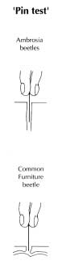Damage
The damage occurs in the forest, the insects attacking standing trees and freshly felled logs, tunnelling into the wood for long distances across the grain. No bore dust. Unlike most woodborers the adult does the tunnelling.

Surface of tunnels are coloured black/blue-black. Holes vary in size depending on which of the Ambrosia beetles caused the damage; many about the same size as furniture beetle holes.

Life cycle:
Varies according to which species of Ambrosia beetle infested the log.

Notes:
The damage is usually confused with Common Furniture Beetle damage but it occurs in the log. These insects cannot infest seasoned timber.

DOES NOT NEED TREATMENT.

Quick Identification:
No bore dust; holes run across the grain long distances (pin test - c/f Common Furniture Beetle). Surface of tunnels coloured black/blue-black.

Since the damage occurred in the log converted wood often cuts holes at an angle which makes them look elongated.

DEATHWATCH BEETLE

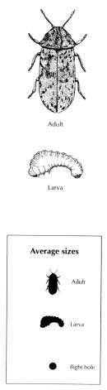(Xestobium rufuvillosum)

Timbers attacked
Sapwood and heartwood of hardwoods, usually oak, which have partly decayed. Softwoods are rarely attacked.

Damage
Extensive tunnelling especially towards centre of large dimensioned timber. Exit holes are round, 3mm diameter. Bore dust is bun-shaped and contains pellets visible to the naked eye.

Damage often more extensive than expected from external appearance.

Life cycle (4+ years)
- Adult: Emerge March - June;
eggs laid 10-20 days after mating.
- Eggs: Laid in cracks and crevices; white, lemon shaped.
- Larva: Crawl prior to boring into
wood; feed and grow for up to 12-14 years.
- Pupa: Develop below surface of
wood in July - August. Pre-emergent adults wait in pupa chamber until following year

Notes:
Adult beetles can often be found on and beneath infested timbers during emergence period. Will fly but require high temperatures.

Quick Identification:
Large bun-shaped pellets; attacks hardwoods.

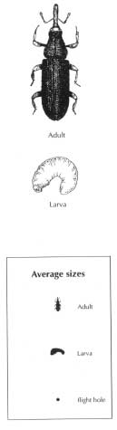WOOD BORING WEEVILS

(Pentarthrum huttoni, Euophryum confine)

Timbers attacked
Any wood that is decayed.

Damage
Tunnels run along the grain just below surface, often exposed. Coarse bore dust, 'gritty' feel. Emergence holes are round but with ragged edges. Damage caused by both larvae and adults, both of which may be found in infested wood.

Life cycle (7-9 months)
  - Adult: Live up to 16 months
and feed on wood with larvae.

  - Eggs: White, laid on or just
below surface.

  - Larva: Curved shape, white.
Bore extensively along grain. Present for 8-9 months.

  - Pupa: Develops just below surface.

Notes
Where weevil damage occurs it is a secondary problem; fungal decay is the primary concern.

Quick Identification
Ragged exit holes; coarse bore dust, tunnels run along grain often breaking the surface. Always in association with fungal decay.

POWDER POST BEETLE

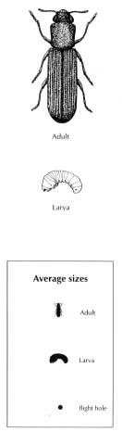(Lyctus brunneus)

Timbers attacked
Sapwood of seasoned wide-pored hardwoods with a high starch content. Timbers over 15 years old not attacked.

Damage
Tunnels tend to run along grain; often causes 'surface' tunnelling where timbers are stacked. Tunnels filled with loose flour-like dust. Round emergence holes 1-2mm diameter.

Life cycle (1-2 years outdoors; 8-10 months indoors)

- Adult: Emerge outdoors July -
August; anytime indoors.

- Eggs: Laid down open vessels;
white, elongated with tail. Hatch in 2-3 weeks.

- Larva: Initially feed and bore along grain.

- Pupa: White; looks more like a
beetle than a larva.

Notes
Unlikely to be found in the average domestic environment. Usually a problem in timber yards or stores of hardwoods, e.g., furniture factories. Where found in a building the origin is usually from such storage areas.

Can be confused with Furniture Beetle damage.

Quick Identification
Hardwoods; loose flour-like frass.

HOUSELONGHORN BEETLE

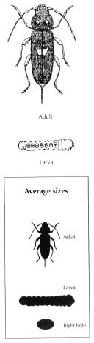(Hylotrupes bajulus)

Timbers attacked
Sapwood of seasoned softwood.

Damage
Very severe tunnelling in sapwood; can lead to structural collapse. Frequently only a thin surface veneer of sound wood remains. Exit holes are oval (5mm x 9mm) and tunnels are somewhat flattened and full of 'sausage' shaped pellets.

Life cycle (4+ years)
  - Adult: Emerge July - September

  - Eggs: Laid in fan shaped pattern in cracks in wood; white spindle shaped. Up to 200 laid.

  - Larva: Feeds in sapwood for more than 4 years. Causes extensive damage; reaches up to 30mm in length.

  - Pupa: Takes place about 3 weeks prior to emergence.

Notes
Damage can be confused with Forest Longhorn damage. Localised distribution around SE England

Quick Identification
Large oval exit holes; loose sausage shaped frass. Tunnels frequently coalesce and not individually identifiable. Ridges on surface of tunnels. Damage internally worse than it appears externally.

FOREST LONGHORNS

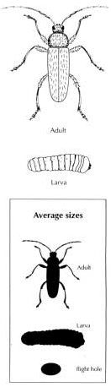(Family: Cerambycidae)

Timbers attacked
Softwoods and hardwoods; standing trees, freshly felled and partly dried barked timbers.

Damage
These form a large group of insects and so damage varies in extent and size. Oval exit holes up to 10mm across. Tunnels very discrete, do not merge; tend to run across grain. No bore dust but tunnels may be plugged with a small amount of coarse fibres.

Life cycle
There are large numbers of Forest Longhorns. The life cycle will vary according to the particular Forest Longhorn attacking the wood.

Notes:
These insects attack wood when it is in the forest; they do not attack seasoned wood. Holes seen when wood is sectioned are tunnels and not emergence holes. Damage often mistaken for House Longhorn damage.

NO TREATMENT REQUIRED.

Quick Identification
Discrete flat tunnels; sometimes plugged with a coarse fibre. If bark is present then surface of wood will be attacked and a lot of bore dust under bark only, not in tunnels.

