Specialist Property Solutions
Identifying Damp in the Home

Damp Category | Signs/Symptoms | Cause | Remedial Work
Rising Damp  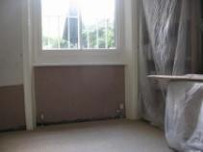 | Dampness and/or staining of internal and external walls, usually at ground level and up to approx 1 metre.  Skirting board decay Rusty nails in the skirting  Wetrot to subfloor timbers i.e. joists, wall plates etc.  Damage to plasterwork, flaking, blistering etc  Salt deposits usually at ground level and up to approx 1 metre. | Missing physical damp proof course (DPC)  Decayed physical damp proof course (DPC)  The physical damp proof course (DPC) is lower than the surrounding groundwork  The physical DPC may also be bridged by extensions or other forms of abutted wall, fence pillars etc. | may require:  Injection of chemical damp proof course to overcome missing/failed physical course (frequent)  Removal & replacement of skirting boards (frequent)  Removal of plaster, sealing brickwork and subsequent replacement of render and finished plaster (frequent)  Replacement of rotting floor timbers (occasional)
Penetrating Damp  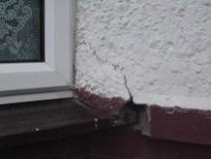 | Dampness and/or staining of internal and external walls, can be present at any height and can propagate to ceilings  Damage to plasterwork, flaking, blistering etc  Salt deposits on walls Timber decay | Loss of integrity to external building construction;  Defective roofing  Cracked render/brickwork Decayed windows/doors Defective guttering | General external building maintenance required (always)  Removal of plaster, sealing brickwork and subsequent replacement of render and finished plaster (frequent)  Removal & replacement of skirting boards (occasional)  Replacement of rotting sub floor timbers (occasional)
Lateral Penetrating Damp  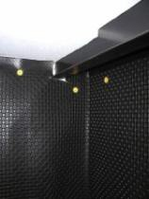 | Dampness and/or staining of internal and external walls, can be present at any height and can propagate to ceilings  Damage to plasterwork, flaking, blistering etc  Salt deposits on walls Timber decay | Missing physical damp proof course (DPC)  Decayed physical damp proof course (DPC)  Raised soil levels or other building works adjacent to external wall | Removal of high external soil levels where practical (occasional)  Removal of plaster and the installation of a tanking system (frequent)  Removal & replacement of skirting boards (frequent)  Replacement of rotting timbers (occasional)
Condensation  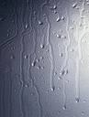 | Staining to interior décor Black mould  Musty odour  Wetness on interior décor, windows/sills | Inadequate ventilation and air circulation  High moisture content in air within home (kitchens, bathrooms etc.)  High temperature fluctuations | Installation of additional sub floor, boiler room air bricks (fairly frequent)  Installation of high level air vents  Installation of ventilation system, ie humidity controlled electric air vents (fairly frequent)  Installation of positive pressure system

Specialist Property Solutions
07725 712012

your solution begins here…

www.specialistspecialistpropertysolutions.org

